



Fundamentals Of Data Science
Assignment 1 Documentation

SUBMITTED BY

Pawan Gyawali
STUDENT ID: 26008001
SECTION A
THE BRITISH COLLEGE

Program 1 – CSV File Reader

Program Description

This program will read the contents of a CSV file called records.csv and display it. It has in-built csv module in Python using DictReader to read in structured student data. The program to verify the presence of the file and all the necessary fields is present and displays the records in a formatted table.

File: q1_read_records.py

Module Used: csv

Input File: records.csv

Fields Read: studentName, roll number, program, year, group.

Key functionality:

Reads csv.csv in read mode using csv.DictReader

Checks that all 5 required column headers are present.

Lists all the records in a well-formatted tabular format with column widths automatically calculated.

Counts the number of records read. •

Handles FileNotFoundError and missing-field errors with easy-to-understand messages.

Testing Screenshots
The screenshot below shows the program reading records.csv and printing the full student table with all fields aligned.
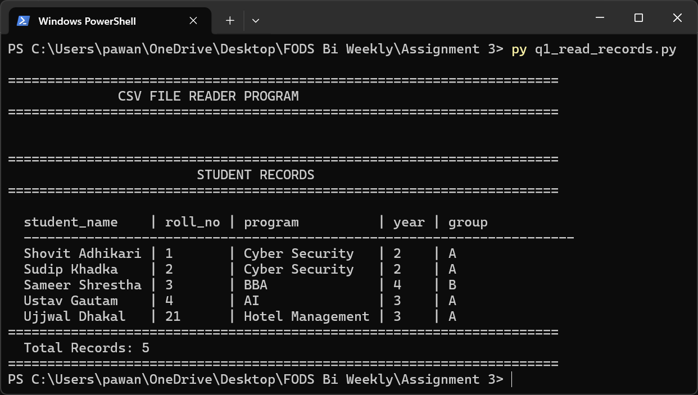
  - Program 1 – CSV File Reader: records.csv displayed in formatted table

Program 2 – CSV File Writer (Append Records)

Program Description

This program will ask the user to input student information and add the newly created record to records.csv. It uses csv.DictWriter in append mode so that existing records are preserved. In case the file is not present, the header row will be written automatically before the first record.

File: q2_write_records.py

Name of the Module: csv, os.

Output File: records.csv

Written Fields: student-name, roll-no, program, year, group.

Key functionality:

Gathers 5 areas of student information in interaction through input prompts.

Adds the record to records.csv without overwriting any data.

Auto writes the first line of the file when it is a new file.

Loops to enable adding of more than one record per session.

Checks yes/no answers and goes on or out.

Testing Screenshots
The screenshot below shows the program accepting student details from the user and confirming the record was appended successfully.
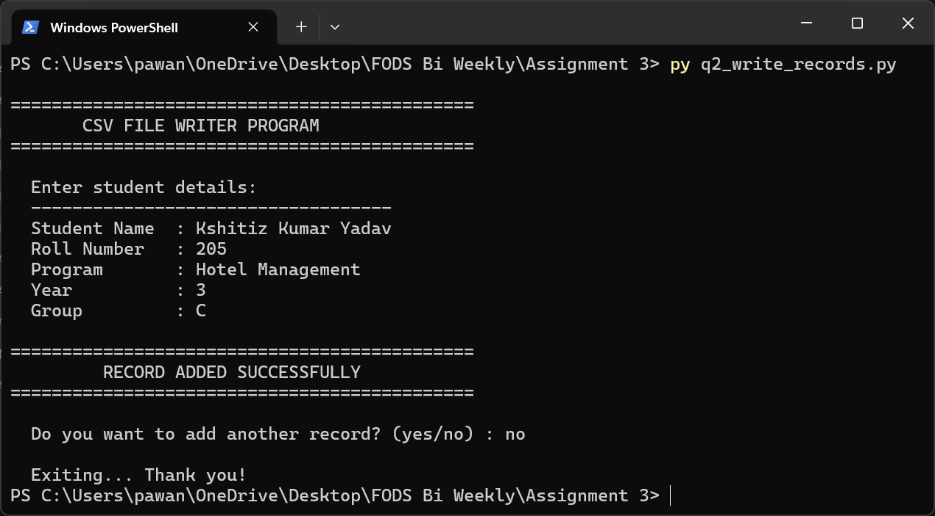
  - Program 2 – CSV File Writer: user enters student details and record is appended

Program 3 – Multi-Operation Calculator with File Logger

Program Description
In this program, the user is required to feed in a list of integers and four arithmetic operations are carried out, including addition, subtraction, multiplication and division. The result of every calculation is logged and added to calculator_log.txt. Upon entering the command exit the program shows the entire log history in a tabular format.
File: q3_calculator_logger.py
Dataset: current time, operating system.
Log File: calculator_log.txt

Key functionality:
- Takes in one or more integers separated by spaces in a single line.
- Addition, subtraction (left-to-right), multiplication and division.
- Catches ZeroDivisionError and records 'Error' for division in that case
- Put a time stamp (YYYY-MM-DD HH:MM:SS) on every session on the log file.
- On exit, prints and shows all the log history in a tabular format.

Testing Screenshots
The screenshot below shows multiple calculation sessions with different integer inputs, the live results displayed after each, and the final log history table printed on exit.
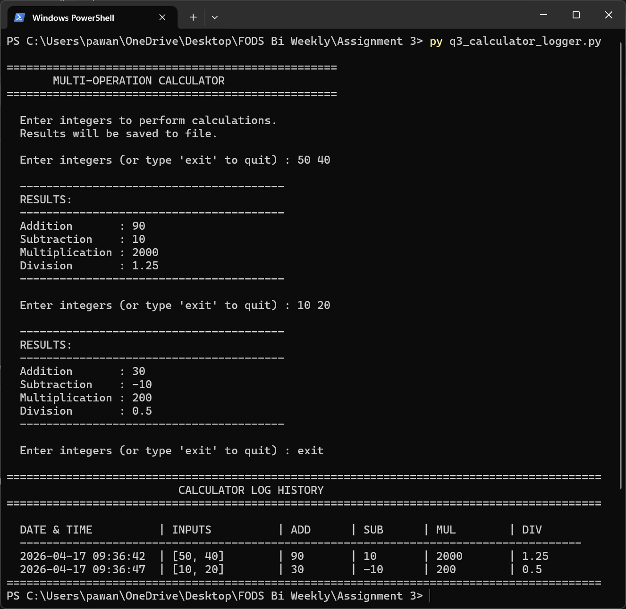
  - Program 3 – Calculator Logger: multiple sessions with timestamped log history

Program 4 – File Copy Program

Program Description
The contents of a single file are copied by this program to a new output file. The user gives filenames of the source and destination. The program exploits the open() method of Python with mode x (exclusive creation) to avoid the overwriting of existing files. Exception handling includes file-not-found, file-already-exists, as well as an unexpected error.

File: q4_file_operations.py
Input File: User-specified (e.g., input.txt)
Output File: User specified (e.g. output.txt)

Key functionality:
- Loads the entire text of the source file. writes to a new file in exclusive create mode.
- Raises FileNotFoundError: Raises an error when the source does not exist.
- Throws FileExistsError when the destination already exists.
- Reports the amount of characters copied successfully.

Testing Screenshots
Three screenshots are provided: the main execution showing a successful copy, and the content of the input and output files confirming that data was correctly transferred.
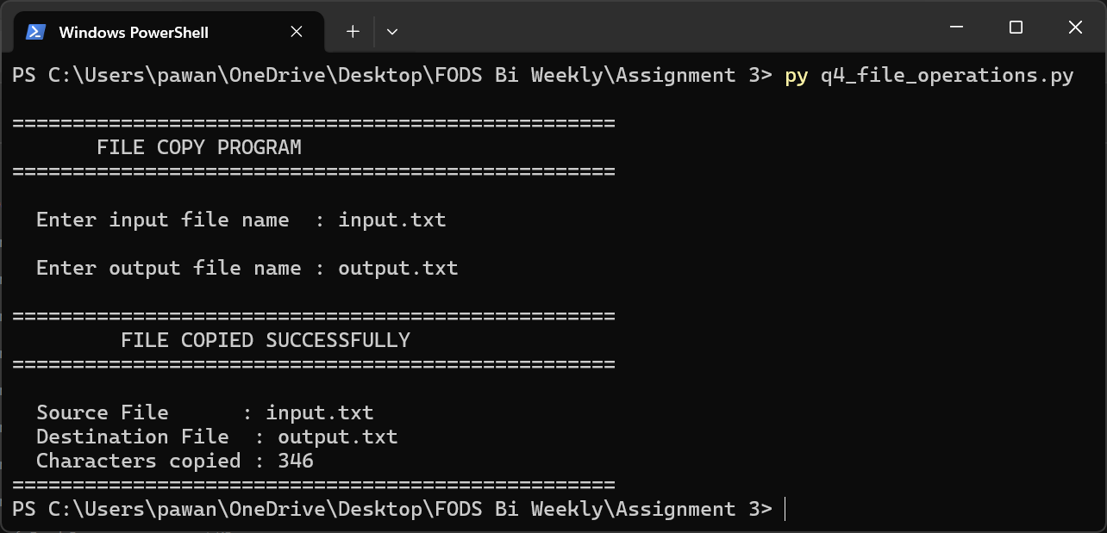
  - Program 4 – File Copy: successful copy showing characters transferred
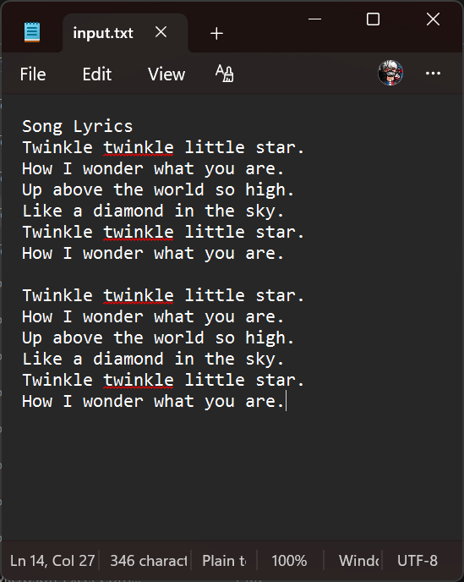
  - Program 4 – input.txt: source file contents
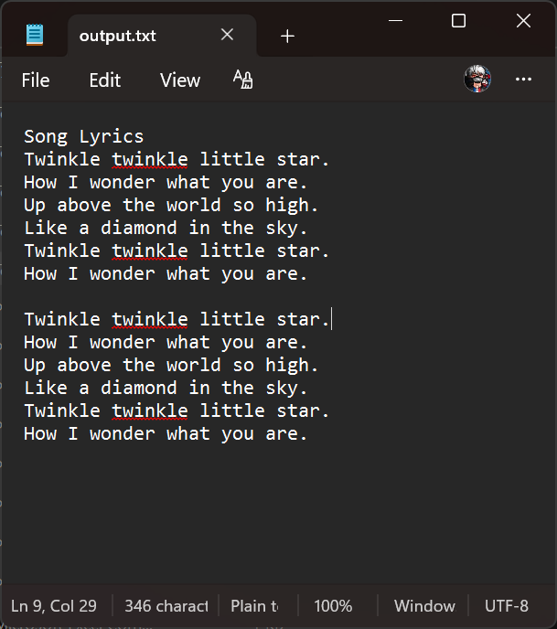
  - Program 4 – output.txt: destination file contents after copy

Program 5 – Learner Class

Program Description
In this program, object-oriented programming is illustrated with the creation of a Learner class. The class contains six attributes of a student and overrides the str method to present a formatted summary. The program creates one Learner object based on the user input and displays it.
File: q5_learner_class.py
OOP Concepts Class definition, __init, __str, encapsulation, instantiating.

Class attributes: roll_no - roll number of the student.
full name - student full name • address – student address
enrollment year- year of enrollment (checked as numeric)
program – study program • group – class group

Key functionality:
- Provides a descriptive __str__ method of defining Learner class.
- Confirms that enrollment year is made of only numbers, re-prompts otherwise.
- Creates a Learner Object and displays a formatted details card.

Testing Screenshots
The screenshot below shows the program collecting all learner fields and displaying the formatted output using the __str__ method.
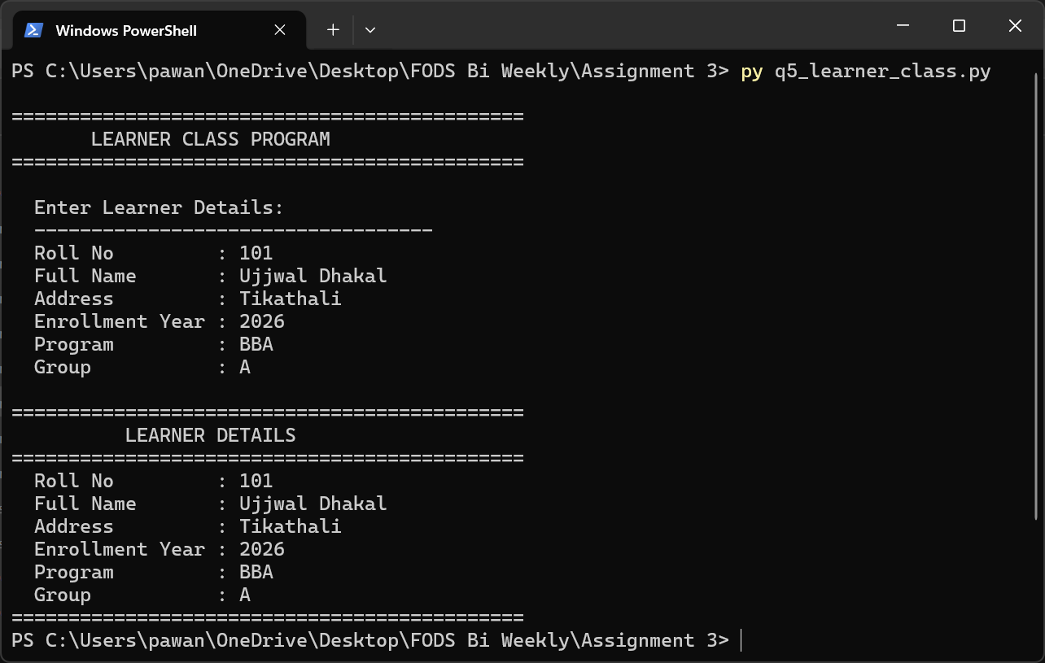
  - Program 5 – Learner Class: user input collected and learner details displayed

Program 6 – Dish and Cookbook Management System

Program Description
This program uses two classes to apply a recipe management system: Dish and Cookbook. The Cookbook class maintains a list of objects of type Dish and serializes them to cookbook.txt. The interactive menu enables people to add, delete, search, and show dishes between sessions.

File: q6_dish_cookbook.py
Persistence File: cookbook.txt
OOP Concepts: 2 classes, composition, file persistence, encapsulation.

Dish class attributes:
dish id, name of dish, ingredients (list), directions.

Cookbook class methods:
- add_dish() - adds a dish and stores to file.
- remove_dish() - removes by dish id and updates file.
- search_dish() - case insensitive name search.
- display_all() -lists all dishes in the cookbook.
- load_from file / save to file - persistent storage.

Testing Screenshots
Five screenshots demonstrate the full menu-driven workflow: main menu, adding a new dish, searching by name, displaying all dishes, and removing a dish by ID.
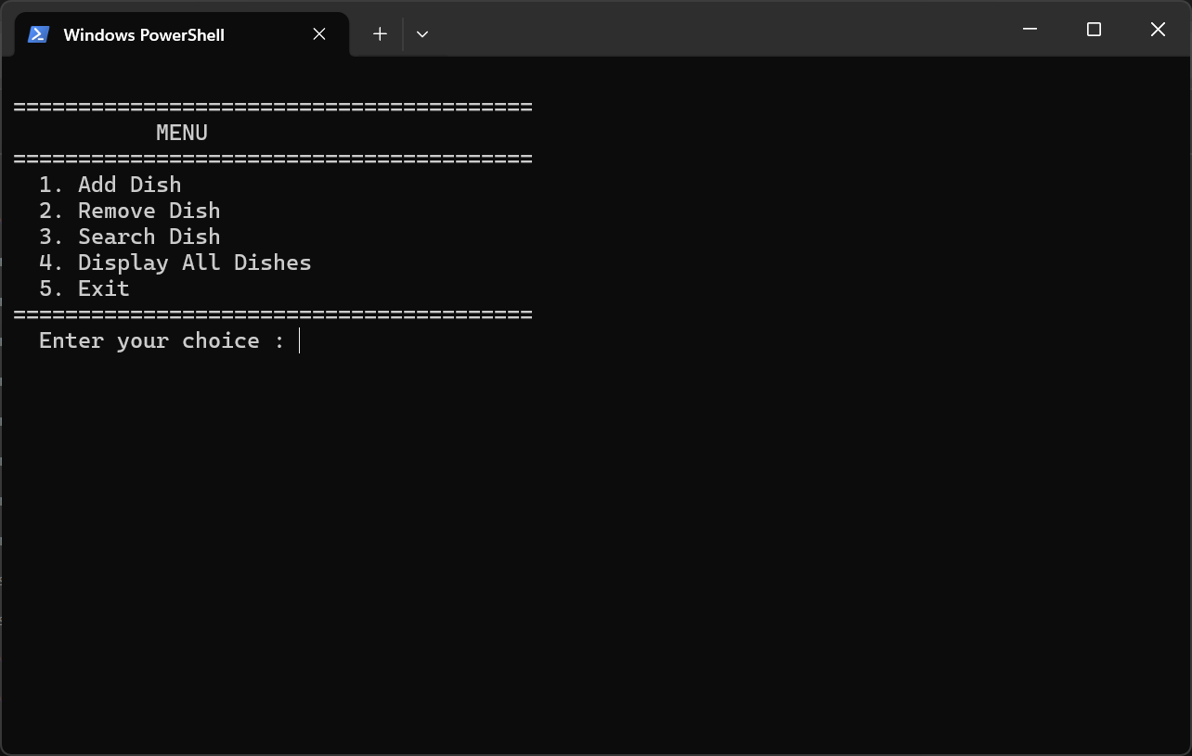
  - Program 6 – Main Menu: interactive menu with 5 options
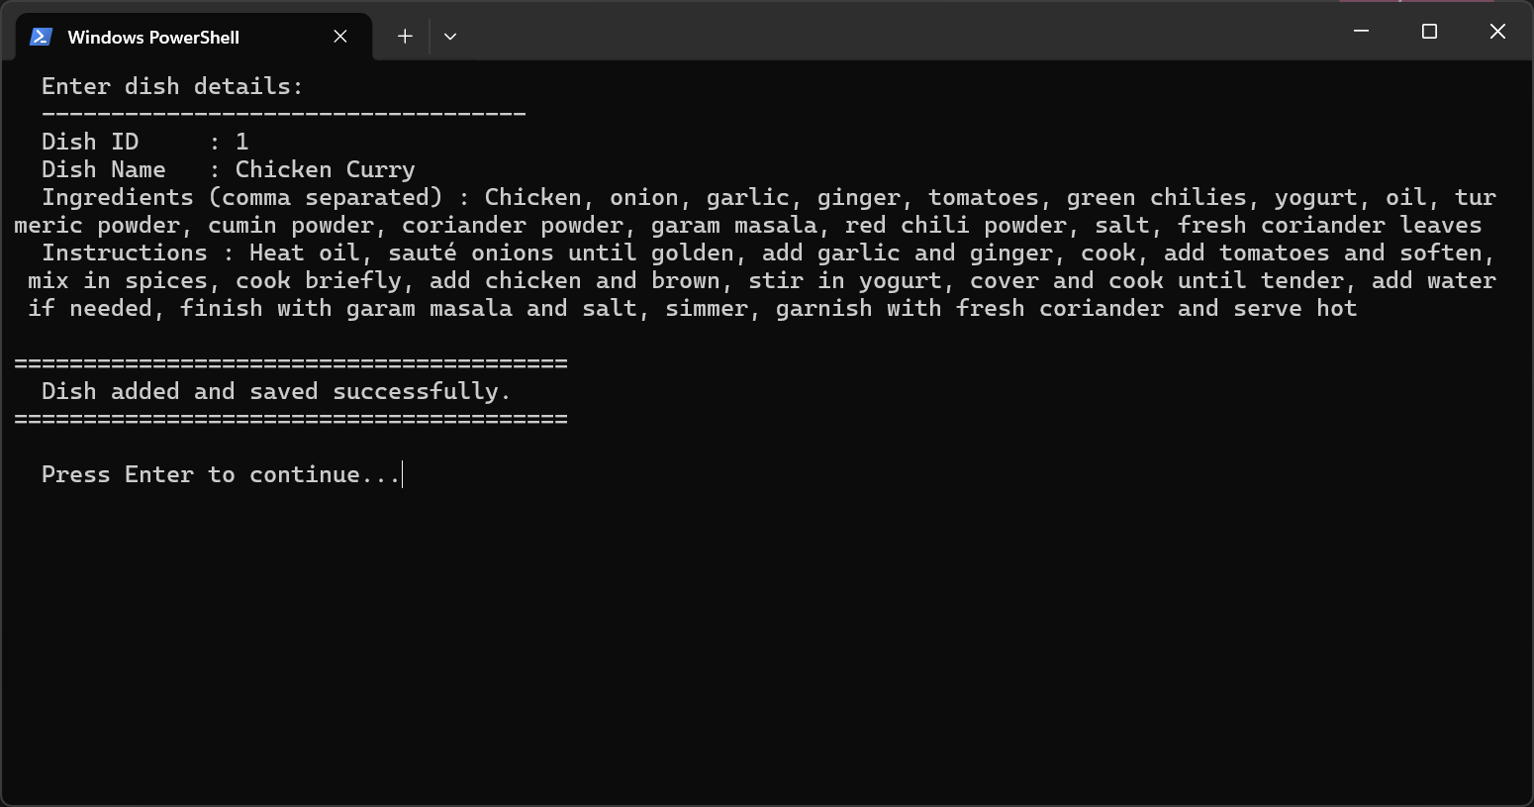
  - Program 6 – Add Dish: entering dish details and confirming save
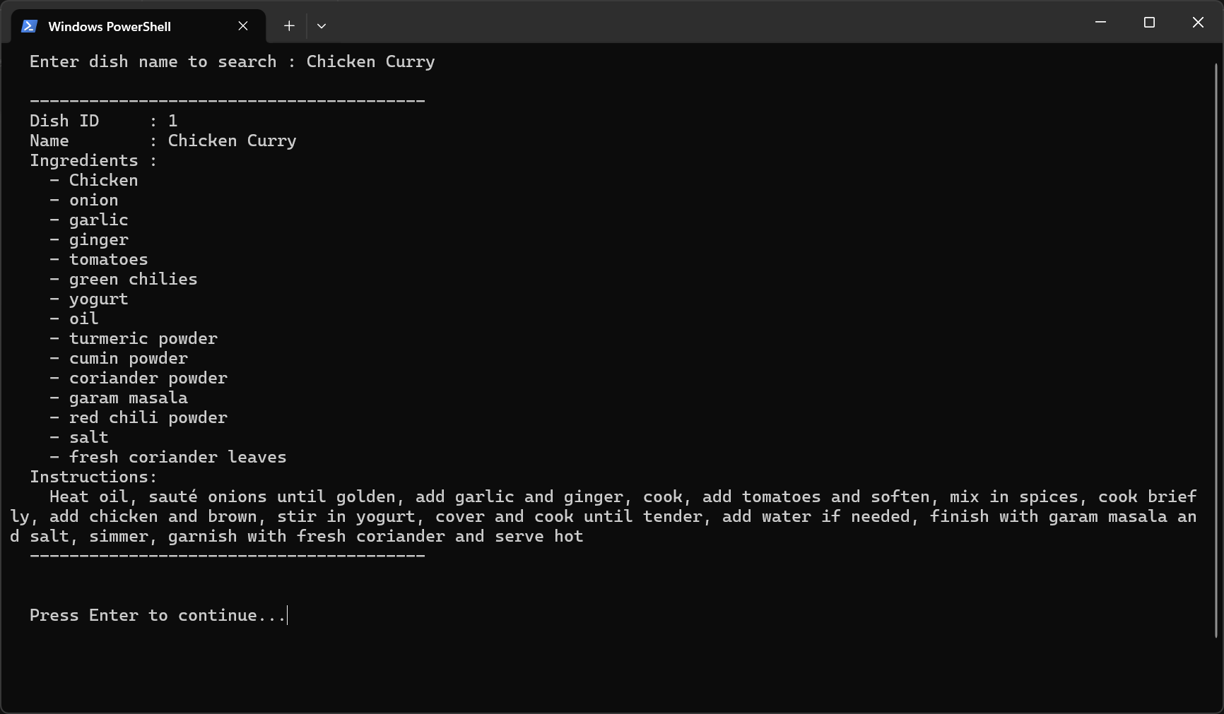
Program 6 – Search Dish: keyword search returning matching results
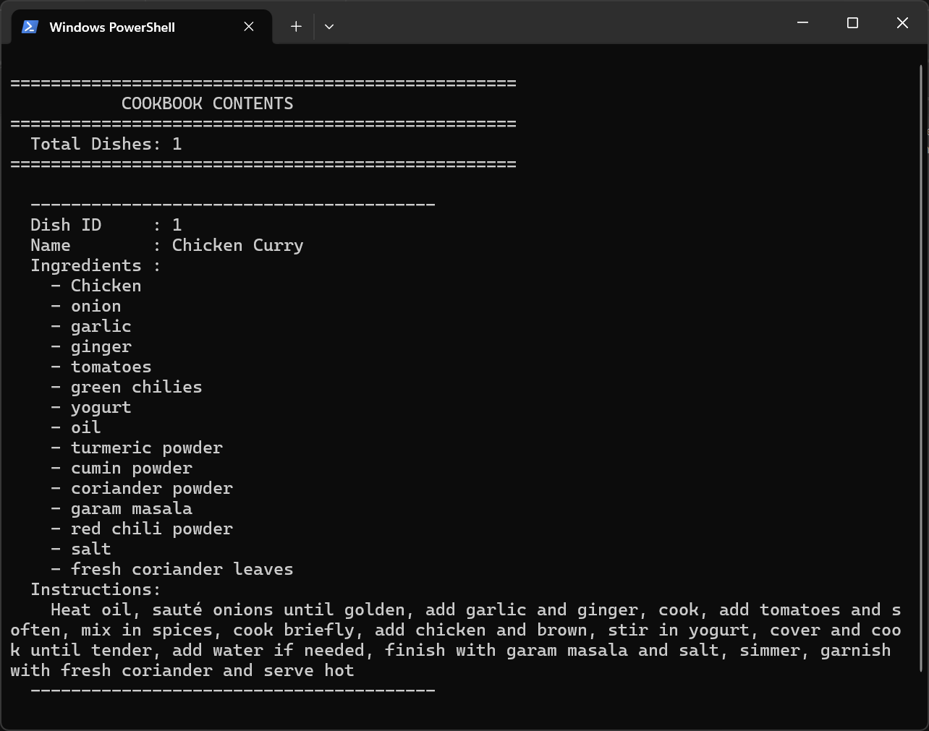
Program 6 – Display All Dishes: full cookbook listing
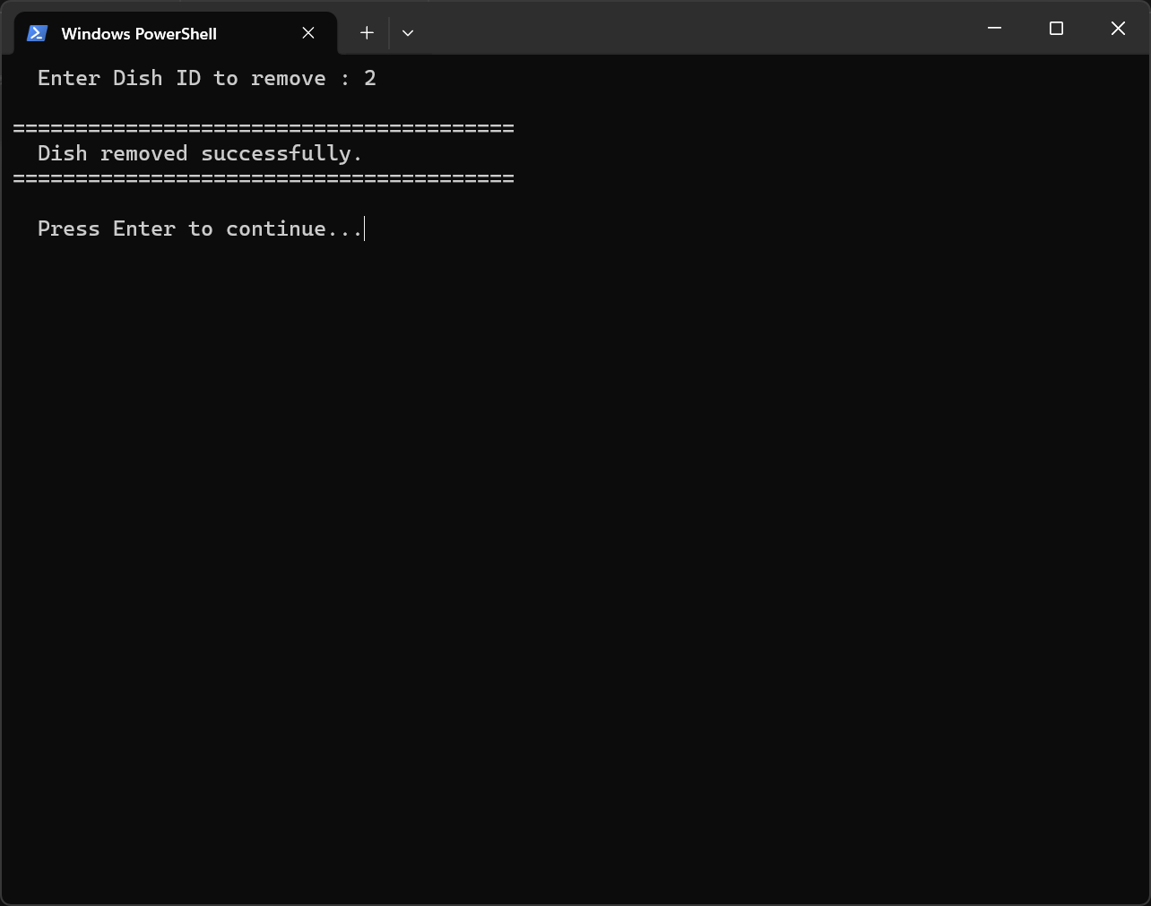
Program 6 – Remove Dish: removing a dish by ID

Program 7 – Staff Management System

Program Description
This program will develop a Staff class to reflect the records of the employees and will offer an interface based on menu to add new staff and see the entire staff list. All data is stored to staff.csv with Python csv. The program loads existing records upon starting the program to ensure that the data is maintained between sessions.
File: q7_staff_management.py
Persistence File: staff.csv
Module Used: csv, os
OOPConcepts: Staff class, encapsulation, CSV file persistence.

Staff class attributes:
emp_id, full-name, address, phone-number, marital-status, dependents, salary.

Key functionality:
- Loads all staff records in staff.csv on startup.
Menu option 1: shows all the staff in a tabular aligned table.
Menu option 2 - asks all 7 attributes and adds to the CSV.
- Exception handling avoids crashing when there is a file I/O error.

Testing Screenshots
Three screenshots show the main menu, adding a new staff member, and viewing the staff table with all records.
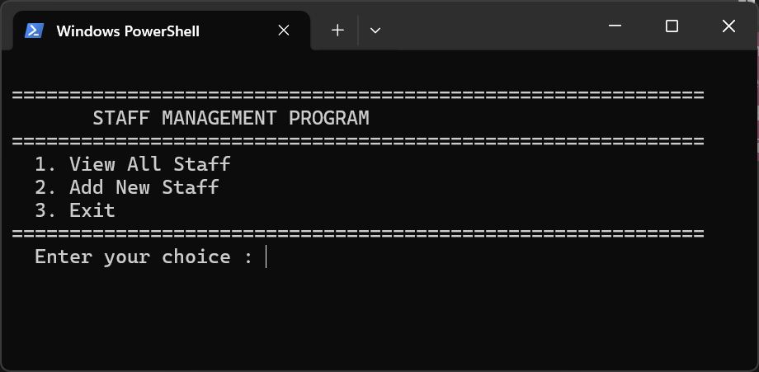
Program 7 – Main Menu: Staff Management program menu
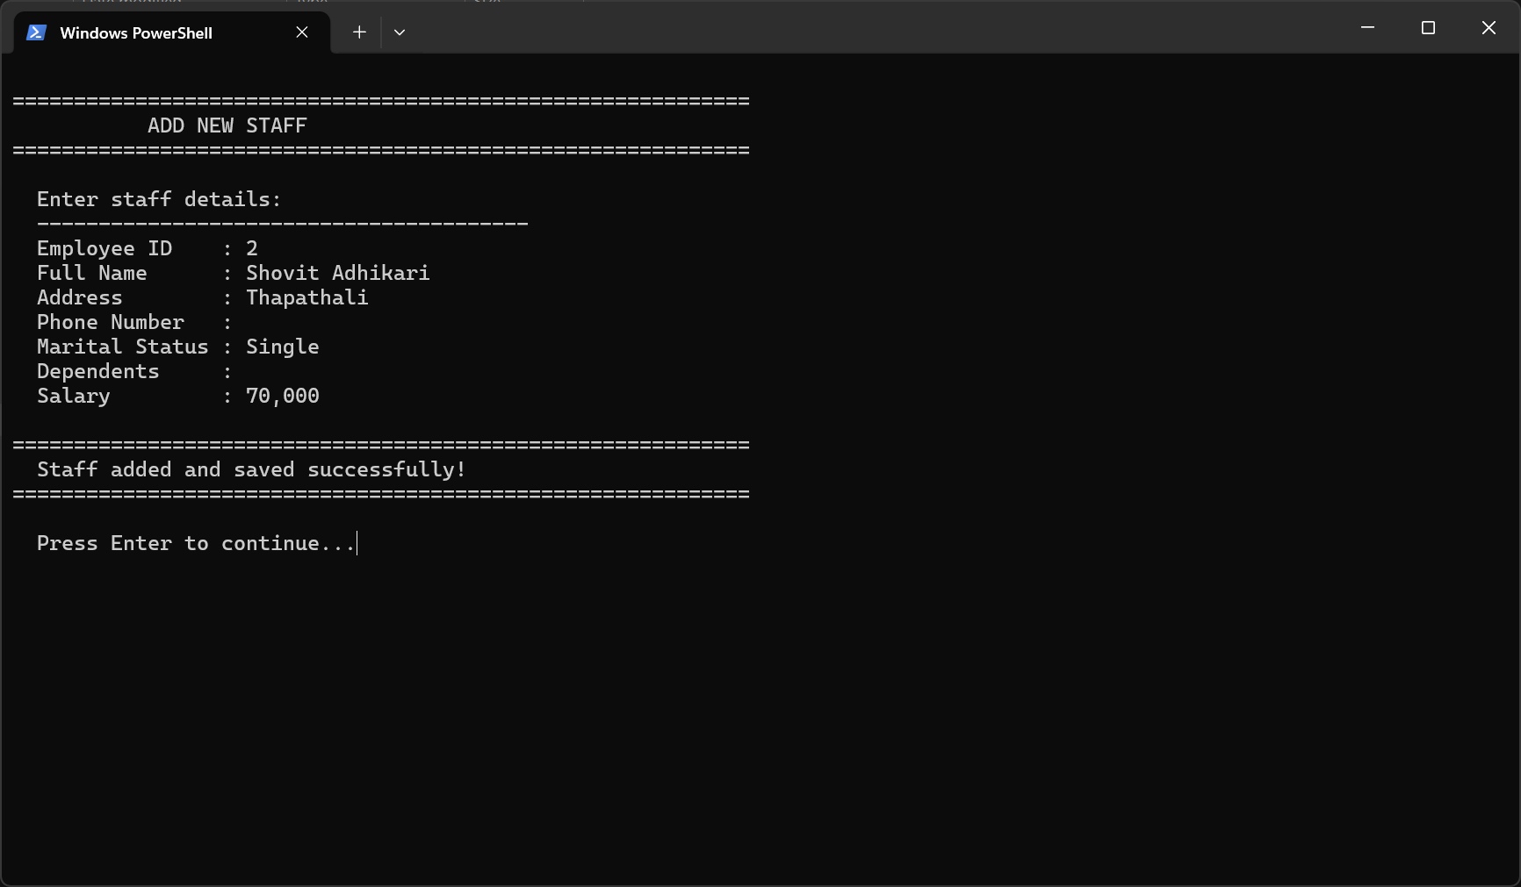
Program 7 – Add New Staff: entering employee details
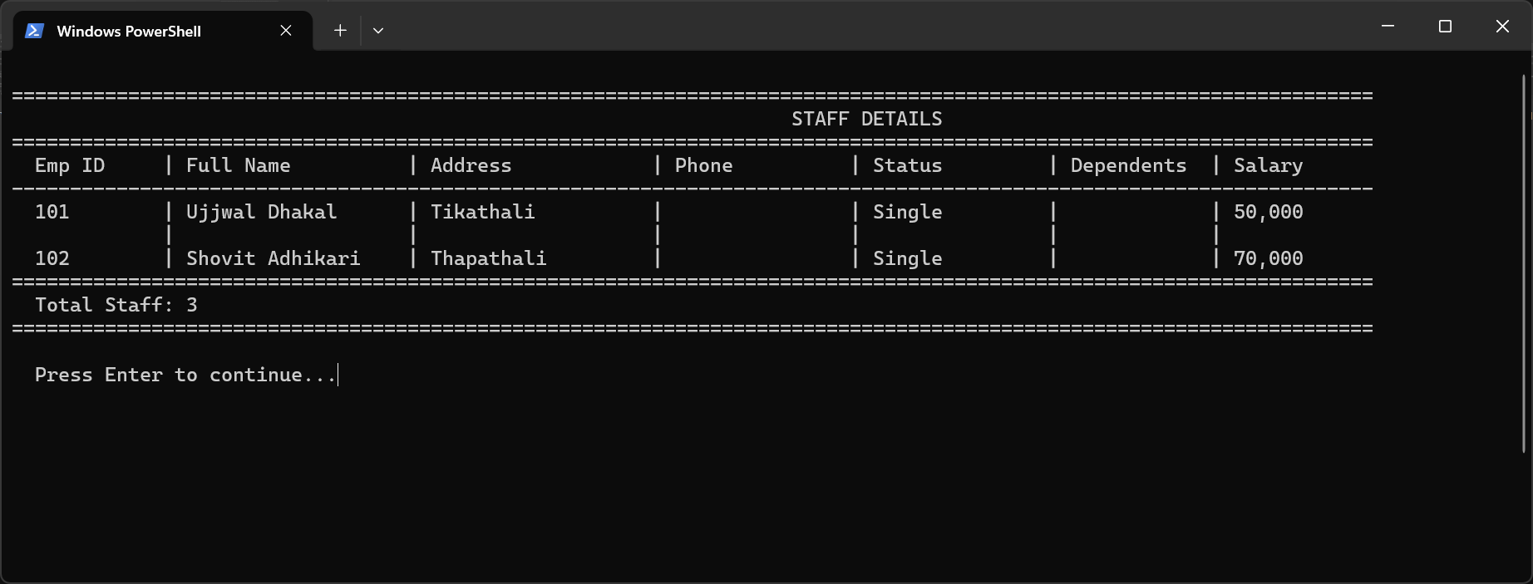
Program 7 – View All Staff: complete staff table from staff.csv

Program 8 – Library Management System

Program Description
The program is a simple library management system that uses two classes: Book and Library. It facilitates the addition of books, searching through titles, borrowing (with borrower details), returning and seeing all books. Books are persisted to books.txt. The system employs encapsulation to control the status of availability of books and the information of borrowers.
File: q8_library_system.py
Persistence File: books.txt
OOP Concepts: Two types of classes (Book, library), encapsulation, file persistence, composition.

Book class attributes: |human|>title, author, isbn, available (bool), borrower name, borrower id

Library class methods:
- add book()- adds book with duplicate check of ISBN.
- search book () - a case-insensitive title search.
- borrow book- sets book to borrow, documents borrower details.
- return book() - verifies that a book is returned, and clears borrower fields.
- view_all books- displays all books, status and borrower details.
- save_books / load_books() - file persistence.

Testing Screenshots
Four screenshots cover the full lifecycle: main menu, adding a book, borrowing a book with borrower details, and returning the book with confirmation.
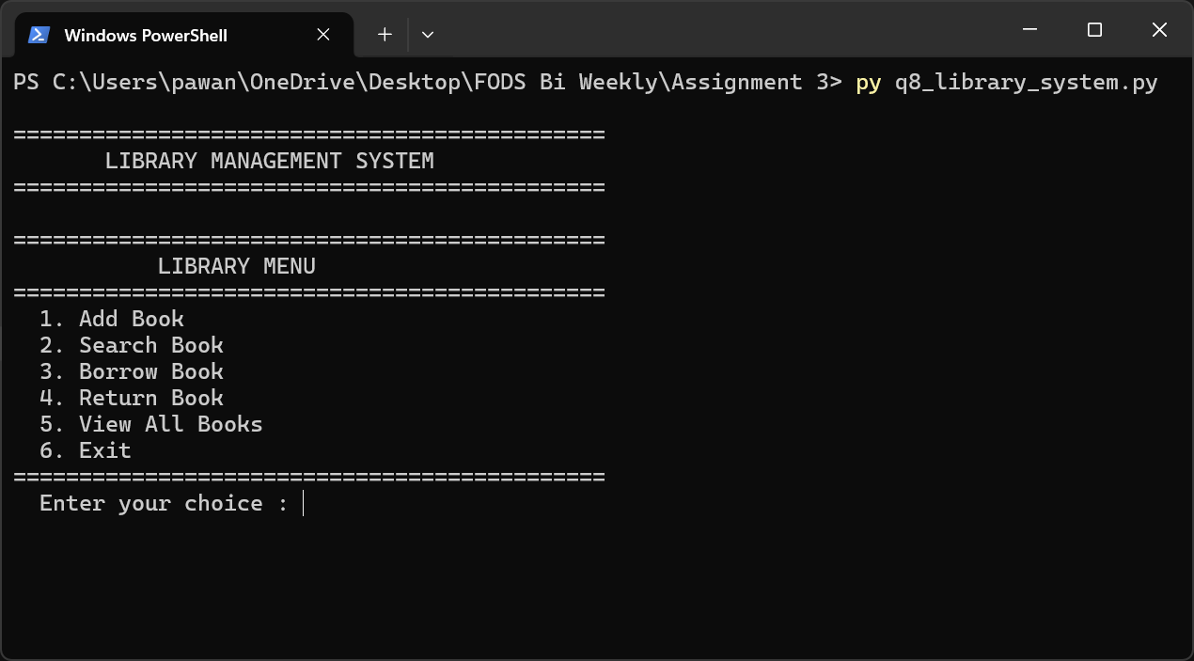
Program 8 – Main Menu: Library Management System with 6 options
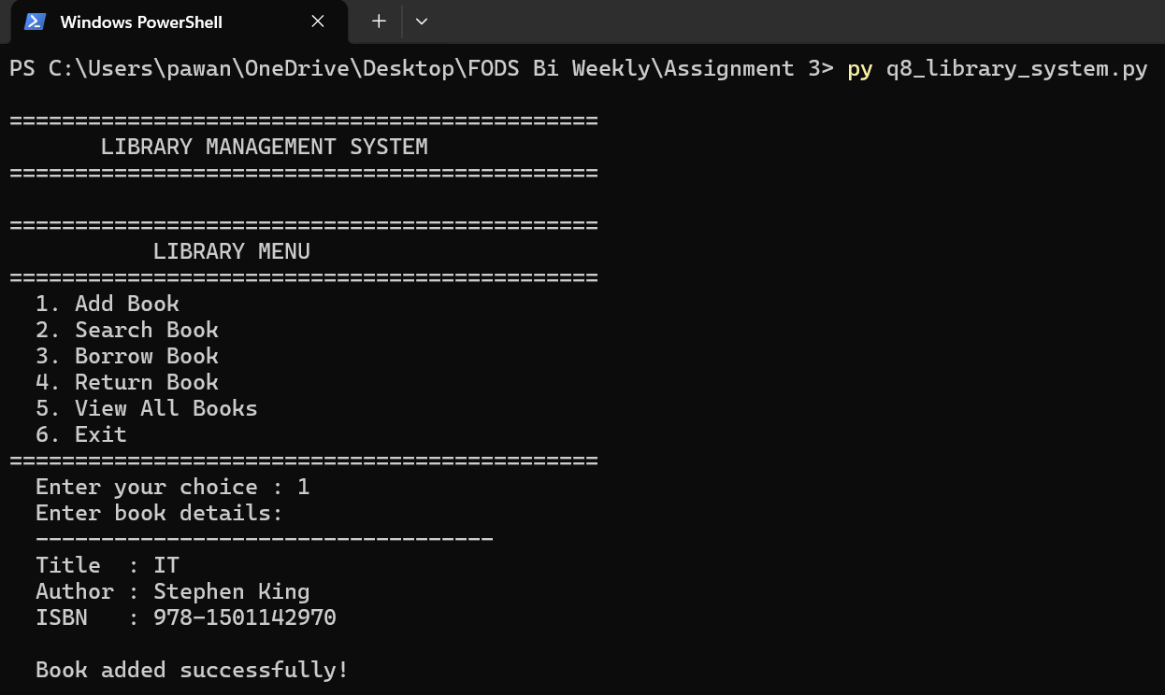
Program 8 – Add Book: entering title, author, and ISBN
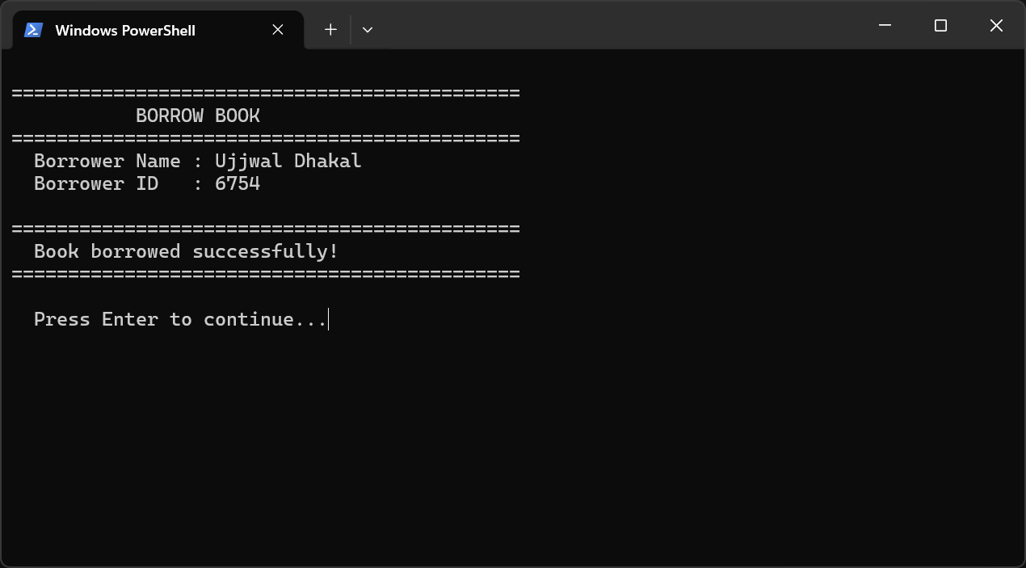
Program 8 – Borrow Book: providing borrower name and ID
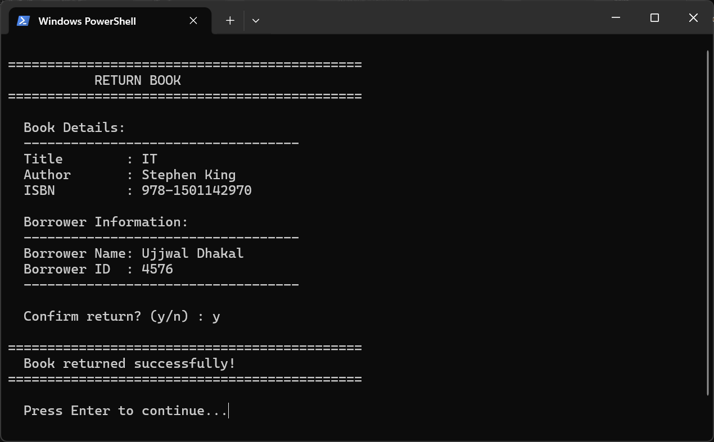
Program 8 – Return Book: confirming return and clearing borrower record

